EXNO:1 Data preprocessing
Aim
To preprocess a dataset using Python by checking and handling missing values, selecting numerical columns, and standardizing the data using StandardScaler.
Algorithm
- Import the required libraries: pandas and StandardScaler from sklearn.preprocessing.
- Load the dataset from the data.csv file.
- Display the first five rows of the original dataset.
- Check and display the missing values in each column.
- Fill missing numerical values with the mean of their respective columns.
- Select the numerical columns: Hours_Studied, Attendance, Assignments, and Marks.
- Create a StandardScaler object to standardize the selected data.
- Apply the scaler to transform the numerical values.
- Convert the standardized data back into a Pandas DataFrame.
- Display the first five rows of the normalized dataset.
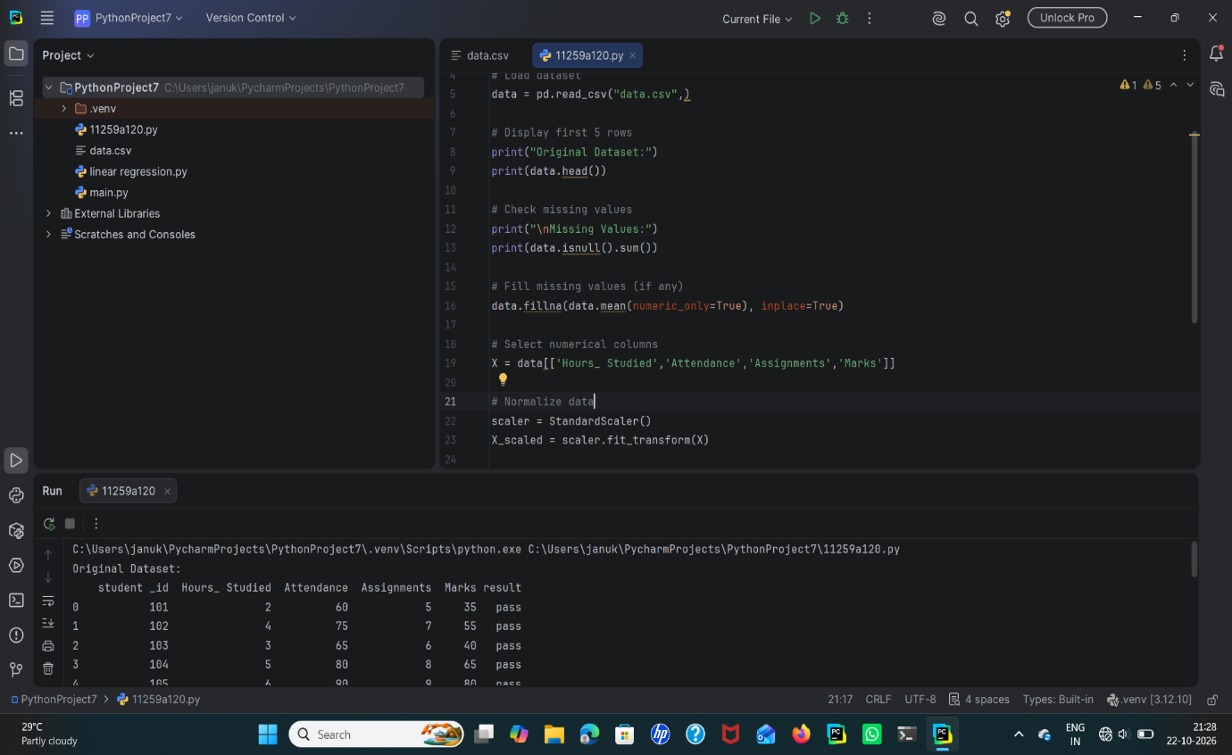
Result
The dataset was successfully preprocessed by checking missing values, filling missingnumerical values with their column means, and standardizing the selected numerical features using StandardScaler. The first five rows of the normalized dataset were displayed successfully.

